Evaluating Voter Sentiment  
between 2016 and 2019

##### Stephen Bookstaber | Lauren Lawless June 4, 2020

Table of Contents

Data 2

Data Questions 2

How do people feel about politics now (2019) based on their previous voting decisions (2016)? 2

Methodology 2

Results 3

What characteristics inform which candidate a person chooses? 5

Methodology 5

Results 5

Can this data inform how people might behave in 2020? 11

Methodology 11

Results 11

Program 13

Part 1: How do people feel about politics now (2019) based on their previous voting decisions (2016)? 13

Part 2: What characteristics inform which candidate a person chooses? 13

Part 3: Can this data inform how people might behave in 2020? 14

Members 14

Conclusions 14

Appendix A: Data and Documentation 16

Appendix B: Survey Questions 17

Appendix C: Logistic Regression Results Summary 21

Works Cited 23

# Data

The data analyzed below originated from the Democracy Fund Voter Study Group VOTER Survey. According to the official documentation:

“The 2019 VOTER Survey (Views of the Electorate Research Survey), completed in January 2019, consists of responses from 6,779 individuals, many of whom participated in prior surveys in 2011, 2012, and 2016. Our unique longitudinal data allow for deep exploration of public opinion on the issues and values that drive voter behavior”

The survey consists of 109 questions, including topics such as issue importance, politician favorability, individual political positions, and personal characteristics. Some questions were repeated each year, some asked only in certain years, and still others asked only once. The data was already in columnar form as a comma delimited file with numeric response labels, so little preprocessing was required other than the elimination of administrative variables, such as respondent identifiers or weighted coefficients, and omission of null values. Other cleansing was performed as needed on a case-by-case basis for each analysis question.

Web links to the documentation files and to request access to the 2019 data or prior years can be found in Appendix A: Data and Documentation.

# Data Questions

## How do people feel about politics now (2019) based on their previous voting decisions (2016)?

### Methodology

The 2019 survey included questions where the respondent rated the degree to which they felt each of the following emotions toward current American politics on a scale from 1 (“do not feel at all”) and 7 (“feel very strongly”): anger, anxiety, disgust, sadness, hope, and enthusiasm. Regret for the respondents’ 2016 vote choices were also rated but as a binary with 1 meaning “yes” and 0 meaning “no”. The results of these questions were isolated and examined both in aggregate and as distributions.

### Results

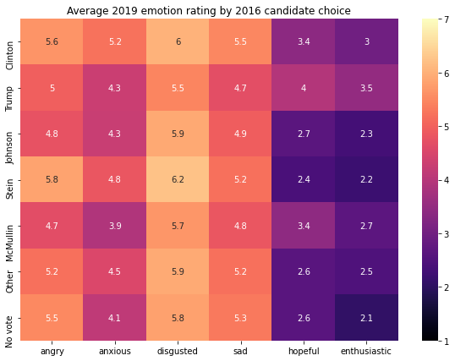 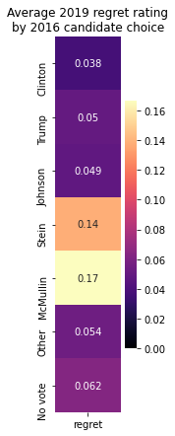

In aggregate, Clinton (Democratic Party), Stein (Green Party), and non-voters feel the highest degrees of negative emotions (anger, anxiety, disgust, and sadness) and, for the most-part, the lowest degrees of the positive emotions (hope and enthusiasm), which predictably signifies high levels of dissatisfaction with Trump’s performance in office over the previous two years. There is, however, a notable exception, in the second case, of Clinton voters, who feel the most hopeful and enthusiastic, second only to Trump voters. This is likely due to the presence of strong party organization on both sides such that Democrats believe that, after a rigorous primary election, they will have found the best candidate to defeat Trump in 2020, and Republicans have faith that Trump will turn out in 2020 the same sort of unforeseen victory that he had in 2016.

Since regret was measured as a binary response, with the 1 representing the affirmative, the average value of regret is equivalent to the proportion of people who answered in the affirmative. Thus, the most regretful voters in 2019 were those who chose to vote for McMullin and Stein, with 17% and 14% of voters reportedly regretting their decisions, respectively. Trump, Johnson, other, and non-voters all express similar amounts of regret (an average of about 5.3%), while Clinton voters have by far the least regret (3.8%). This reinforces the relatively high responses in the other negative emotion rankings in that Clinton voters would feel justified in their decision and others who do not think Trump has done well as President would express guilt for not having prevented his victory.

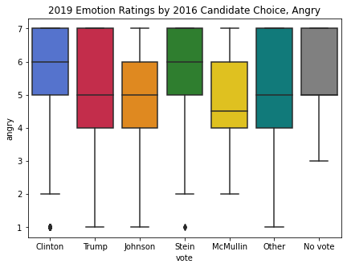 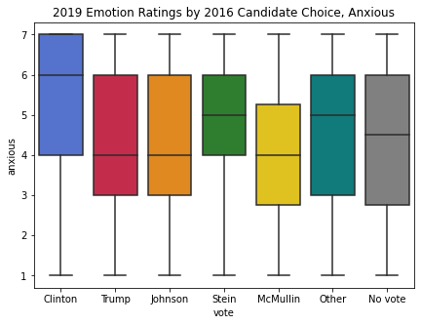

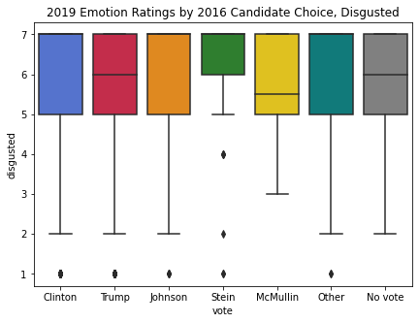 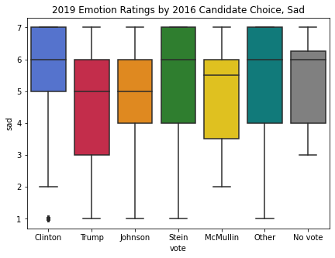

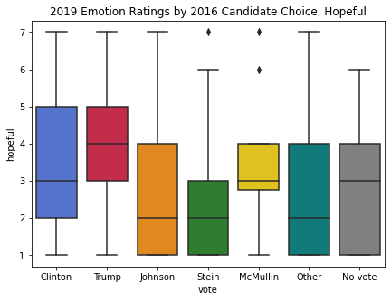 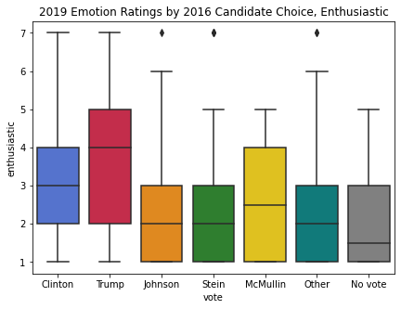

When looking at individual distributions by candidate choice, more nuanced interpretations of the results are demonstrated. For example, comparing the distributions of Clinton and Stein voters across the negative emotions shows similar levels of anger but higher overall anxiety and sadness among Clinton voters and higher disgust among Stein voters. This could be interpreted by some as the impact of having high expectations of victory in 2016 among Clinton voters, leading to sadness about the outcome and anxiety about the future compared to general outrage among Stein voters without the effect of loyalty to the party or agenda.

Likewise, comparing reported levels of disgust across vote choice shows approximately equivalent distributions across candidates with some natural variation in the median values. While this indicates that all voters are approximately equally disgusted by the current political climate, one would be remiss to assume that they are disgusted for the same reasons.

## What characteristics inform which candidate a person chooses?

### Methodology

In order to determine what was most influential in a person’s choice of candidate, the most divisive questions from the 2016 survey were isolated. Included were questions where the at least one response option showed an average selection margin between Clinton and Trump voters of at least 0.5, meaning that many more voters from one group selected that option compared to voters from the other group. The results can be split into two categories: social issues—such as race, gender, immigration, etc.—and policy issues—such as government size and influence, climate policy, and healthcare, which are discussed below.[1]

### Results

##### Social Issues

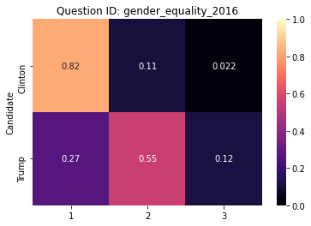 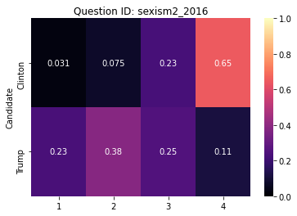

Issues of gender and sexism draw a pretty clear line between the two groups of voters. As seen above, Clinton voters acknowledge that men have more opportunities than women and that the pursuit of gender equality is based in true equality rather than “special treatment”, whereas Trump voters tend to be more skeptical of the motivations of the feminist agenda.

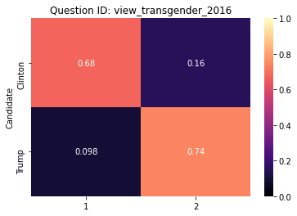 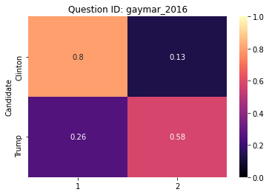

On LGBTQ+ issues, Trump voters are similarly averse to the pursuit of equality. The proportions of each voter group on the issue of gay marriage are approximately equal to the proportions on the question of equal opportunities for men and women, showing minimal acknowledgment of validity in the argument.

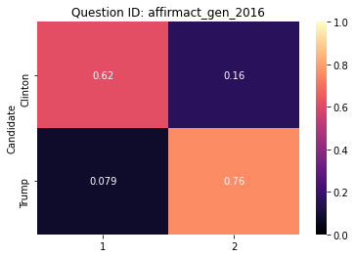 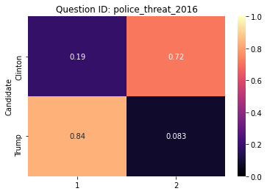

The responses to the question about affirmative action demonstrates the interconnectedness of sexism and racism, i.e., that policies that attempt to correct for racial and gender-based privilege are seen by Trump voters as unfair, advantageous treatment toward groups that benefit from them. Focusing then on race, the opinion held by most Trump voters that police killings of Black citizens are individual, isolated incidents stands unsurprisingly in stark contrast with the opinion of most Clinton voters that the killings are part of a broader pattern of institutional racism.

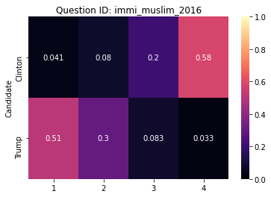 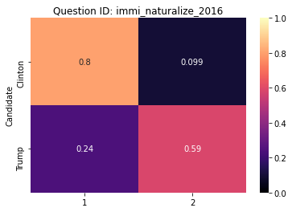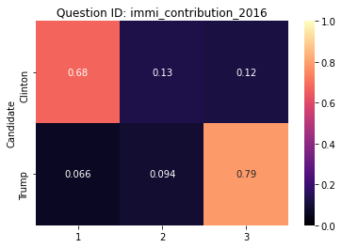

Trump voters’ views of race also inform their positions on immigration, leading most to believe that immigrants should not be allowed into the country as they are an overall drain on society, whereas Clinton voters see value in a diverse society, thus believing that currently undocumented immigrants should be given a path to citizenship and that immigration should not be prevented based on another country’s religious makeup.

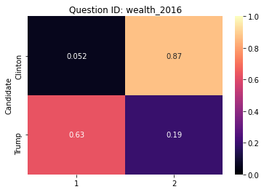 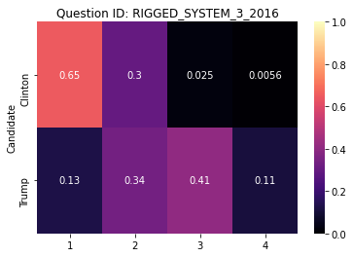

Clinton and Trump voters fundamentally disagree on how wealth should be distributed, although Trump voters somewhat recognize that the current economic system favors the wealthy.

#### 

Trump voters are overwhelmingly distrustful of the mainstream media, which is almost certainly derived from Trump’s personal tendency to attack media outlets that disagree with him as “fake news”.

##### Policy Issues

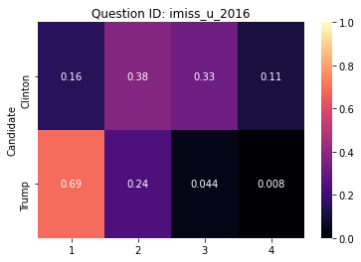

The size of the government is an extremely important issue to Trump voters, whereas it is only moderately important to Clinton voters.

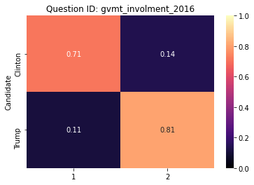 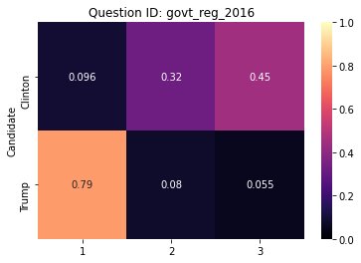

Adding the context of the divide between voter groups on the involvement of the government in the economy, specifically, it is evident that Trump voters strongly prefer small government, while Clinton voters passively prefer a strong and influential federal government.

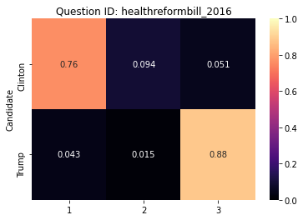 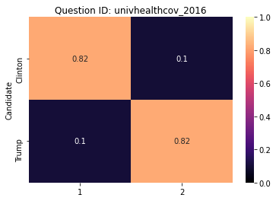

This difference in political philosophy is evident in the responses to questions about the Affordable Care Act and universal healthcare, with Clinton voters supporting expansion of the former and Trump voters supporting total repeal.

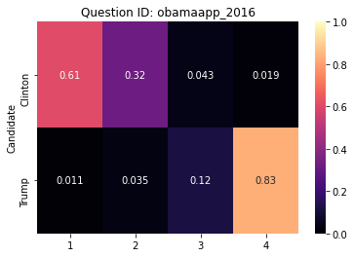 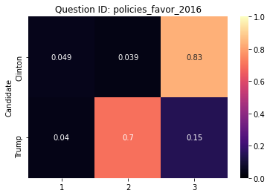

Tangentially, this position on the Affordable Care Act (also known as Obamacare) is likely confounded by the legislation having been passed under the Obama administration and is, therefore, seen as blighted by Trump voters, who report high levels of overall disapproval of Obama. Further, this disapproval is informed by Trump voters’ positions on race, as they overwhelmingly believe that the Obama administration’s policies favored Black Americans over White Americans, whereas Clinton voters consider them to have overall racially equal outcomes.

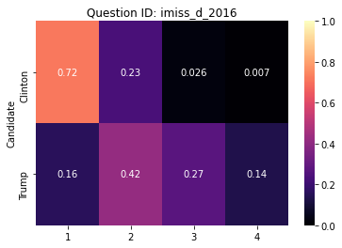 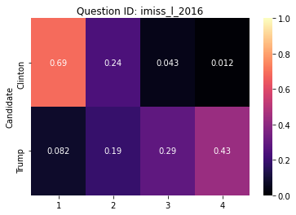  
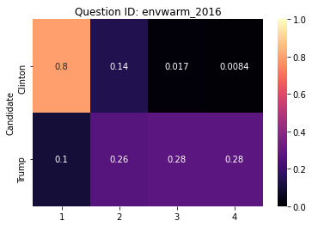 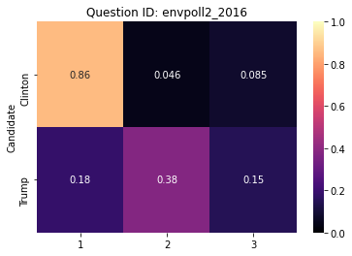

Returning to the primary point of division between strong and weak government philosophies, the same opinions are reflected in questions regarding the environment and climate change, where Clinton voters report high issue importance for both topics since they are more likely to believe scientists’ claims that Earth is warming due to human activity, while Trump voters are skeptical of global warming and mostly reject that it is due to human activity. Curiously, however, the issue of climate change shows low to high levels of importance to Trump voters, whereas the issue of the environment is primarily reported as “somewhat important” with decreasing reports of lower importance, indicating that Trump voters might otherwise weight climate change as a more important issue if they didn’t reject the premise entirely.

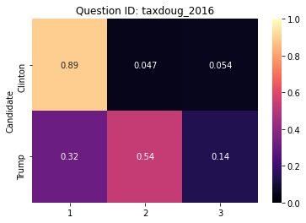

Finally, while there is still a large margin of response selection between the two voting groups, there is a slight break in the small government philosophy among Trump supporters when asked about increasing taxes on families with greater than $200,000 in income per year. The responses to this question reflect the same position of Trump voters that economic policies mostly favored wealthier people, but it is notable that they would not consider this to be redistribution of wealth, to which they are mostly opposed. The dissection of the political philosophy behind this difference in reasoning is complex and beyond the scope of analysis here.

## Can this data inform how people might behave in 2020?

### Methodology

The 2016 responses were split into training (45% of examples) and testing (55% of examples) sets. A logistic regression model was applied to the data in order to evaluate the predictive power of these topic questions in estimating the likelihood of a vote for one candidate or party over another—in this case, a dependent variable was used where a value of 1 indicates a vote for Clinton, and a value of 0 indicates a vote for Trump, with all other voters and non-voters being removed from the set of examples. A preliminary model was run to identify statistically significant variables, after which a second model was run using only those significant variables.

After these models produced satisfactory results, the significant 2016 variables were checked against 2019 questions, and repeated questions were isolated for a second, smaller regression. The same strategy was used in building the model, after which the model was applied to 2019 responses to predict 2020 candidate choice.

### Results

The figure below shows the correlation strength and direction between all variables, with strong positive correlations appearing in dark blue, strong negative correlations appearing in dark red, and weak correlations appearing in lighter shades or white.

While there is some expected correlation between related topics, such as between imiss_y_2016 (issue importance: gender equality) and imiss_g_2016 (issue importance: gay rights), there are none that are so correlated to justify their elimination from the models.

After insignificant variable elimination, the first model predicted 2016 candidate choice between Clinton and Trump with 93.46% accuracy against the test data set. There are 45 significant variables, including some of the divisive topics discussed previously, such as the immi_muslim_2016 (Muslim ban), envwarm_2016 (global warming), and govt_reg_2016 (corporate regulation).[2]

Of the 45 significant variables used in the first model, 20 were asked again in 2019. The logistic model produced from those 20 variables predicted 2016 candidate choice in the test data with 90.45% accuracy, which, while not negligible when projected over millions of voters, is a relatively small loss considering that the number of variables used was halved.

Using this model, the candidate choice for the 2020 election was predicted based on 2019 responses, producing an estimated 2,802 votes (53.70%) for the Democratic candidate over Donald Trump. This number can be compared to the 2,541 respondents (52.54%) who indicated that they would vote for the Democratic candidate over Donald Trump in 2020 (vote2020_2019).[3]

# Program

The code is split into three parts to answer each of our questions. Initial preprocessing involves importing the .csv of all voter survey questions and responses. No changes were made directly to the .csv prior to importing into the program. Next, separate data frames are created for the survey years 2016 and 2019. Additional preprocessing steps are performed for each of the following parts.

## Part 1: How do people feel about politics now (2019) based on their previous voting decisions (2016)?

Preprocessing involves creating a data frame of the survey questions related to “emotions” and feelings about past voting decisions. We also include the column “presvot16post_2016”, which represents the respondent’s actual vote in the 2016 election and is used in all of our data frames for analysis. We use a dictionary to store the list of candidate names as keys and the corresponding integer response used in the survey as values.

The emotion survey questions ask the respondent about the degree to which they feel a given emotion on a scale of 1 to 7. We create a data frame with candidates as the index, survey questions as the columns, and the mean value of the responses as the values. The data frame and corresponding boxplots/heatmap are the outputs for Part 1.

## Part 2: What characteristics inform which candidate a person chooses?

Preprocessing involves taking the data frame of 2016 questions/responses and removing columns for the following survey questions: zip code, state, weight, all columns that permitted open-ended, string typed responses, candidate-specific questions, and questions that do not relate to a political topic. From the remaining columns, we create a multi-index pandas data frame, with the first index being the candidate, the second index being the topic, and the columns being a list of possible integer responses. Then, for each topic, we aggregate the respondents by the candidate they voted for and record the relative proportion of each answer as the data frame values.

Next, we want to identify which topics were the most divisive, as the respondent’s answers to these topics would likely be most informative of the candidate a person chooses, which we find in Part 3 to be true. We measure divisiveness by calculating the absolute value of the difference between Clinton and Trump voters for each survey question. If the difference for any response is greater than our threshold of 0.5, the topic is considered divisive. We create a subset of the larger multi-index data frame for each topic for visual analysis.

## Part 3: Can this data inform how people might behave in 2020?

Preprocessing involves creating a new data frame from the original data frame of survey questions from 2016 and removing any questions specifically related to party and candidate. Then, we use an experimental module from the sklearn package called IterativeImputer to impute missing values. Lastly, we create a subset of the data frame to only include those who voted for Clinton or Trump in 2016. This sets up the data frame for a logistic regression where the output, y, is the candidate for whom a person voted in 2016.

Using the sklearn library, we split the data into train and test data using the train_test_split module and perform the regression using the LogisticRegression module. We evaluate the model accuracy, including the significant input variables, using the statsmodel.api library. A loop performs the regression, evaluates the predictors chosen by the model, and strips away variables with a p-value greater than 0.05 until we have a final model containing only significant inputs. For each topic, we create a correlation matrix using the pandas corr() function.

Finally, the significant variables from the model are compared to the columns of the 2019 data frame, and repeated questions are identified by having the same column name but ending in “2019” rather than “2016”. A new model is built using only these repeated columns from the 2016 data, which, again, is applied to the test set to determine accuracy. The model is then applied to 2019 responses to the same questions to predict the proportion that would vote for the Democratic candidate in 2020.

# Members

The members of the group split responsibilities relatively equally. While Lauren defined the research questions and made domain knowledge-informed suggestions for how they could be answered given the data collected, Stephen did most of the heavy lifting in Python to get the raw data into the proper format. After the data was available in a more appropriate configuration, Lauren built visualizations of the data and provided analysis of the results, again informed by domain knowledge. Stephen was responsible for describing the process of data collection and preparation that was conducted, and Lauren prepared the project deliverables for submission.

# Conclusions

The 2019 data set overall reflects a nation, divided over social and philosophical issues, that has mostly taken one of two political parties as a source of higher purpose (so-called “identity politics”). While one side is interested in the collective, the other is primarily interested in self, but which side is which depends heavily on which side one stands. The election of Donald Trump in 2016 was a result of that division that some, but not many, have come to regret. Regardless of candidate choice, most people are apoplectic or despondent, seeing little reason to feel optimism toward our political future.

That said, the consistency with which people use the opinions they hold to inform their choice of political candidate every four years is seemingly unwavering. In 2016, people voted on their deepest-held beliefs: that the world is in danger of rising global temperatures, that some minority groups deserve certain legal protections, or that everyone has the same chances so no one should need anything from the government. Whatever these beliefs and however they might have changed from one person to the next, they still demonstrably impact for whom a person will cast their ballot, so if shifts in opinion are able to be documented, such as they are by the longitudinal data examined here, then a reliable prediction of that individual’s eventual decision is able to be made.

# Appendix A: Data and Documentation

Request to download 2019 data and read 2019 documentation:  
<https://www.voterstudygroup.org/publication/2019-voter-survey-full-data-set>

Parallel links to prior years of the survey (2016, 2017, and 2018) and documentation:  
<https://www.voterstudygroup.org/data>

# Appendix B: Survey Questions

|  |  |  |
| --- | --- | --- |
| **Question ID** | **Question** | **Response Labels** |
| accurately_counted_2016 | How confident are you that the votes in the 2016 election were accurately counted? | 1. Very confident 2. Somewhat confident 3. Not too confident 4. Not at all confident |
| accurately_counted2_2016 | How confident are you that the votes in the 2016 election across the country were accurately counted? | 1. Very confident 2. Somewhat confident 3. Not too confident 4. Not at all confident |
| affirmact_gen_2016 | Do you generally favor or oppose affirmative action programs for women and racial minorities? | 1. Favor 2. Oppose |
| amcitizen_2016 | How much do you agree or disagree with the following statement? I WOULD RATHER BE A CITIZEN OF AMERICA THAN ANY OTHER COUNTRY IN THE WORLD | 1. Agree strongly 2. Agree 3. Disagree 4. Disagree strongly |
| Americatrend_2016 | In general, would you say like in America today is better, worse, or about the same as it was fifty years ago for people like you? | 1. Better 2. About the same 3. Worse |
| amshamed_2016 | How much do you agree or disagree with the following statement? THERE ARE SOME THINGS ABOUT AMERICA THAT MAKE ME FEEL ASHAMED OF AMERICA | 1. Agree strongly 2. Agree 3. Disagree 4. Disagree strongly |
| deathpen_2016 | Are you in favor or opposed to the death penalty for persons convicted of murder? | 1. Favor the death penalty 2. Opposed to the death penalty |
| econtrend_2016 | Overall, do you think the economy is getting better or worse? | 1. Getting better 2. About the same 3. Getting worse |
| educ_2016 | What is the highest level of education you have completed? | 1. NoHS 2. High school graduate 3. Some college 4. 2-year 5. 4-year 6. Post-grad |
| envpoll2_2016 | Do you think global warming has been caused by pollution from human activities (such as emissions from cars and factories) or by natural causes? | 1. Pollution from human activities 2. Natural causes not related to human activity 3. Don't know |
| envwarm_2016 | Some people say that global temperatures have been going up slowly over the past 100 years - the phenomenon called "global warming." Do you think that global warming is happening? | 1. Definitely is happening 2. Probably is happening 3. Probably is not happening 4. Definitely is not happening |
| fair_people_2016 | Do you think most people would try to take advantage of you if they got a chance, or would they try to be fair? | 1. People would try to take advantage 2. People would try to be fair |
| faminc_2016 | Thinking back over the last year, what was your family's annual income? | 1. Less than $10,000 2. $10,000 - $19,999 3. $20,000 - $29,999 4. $30,000 - $39,999 5. $40,000 - $49,999 6. $50,000 - $59,999 7. $60,000 - $69,999 8. $70,000 - $79,999 9. $80,000 - $99,999 10. $100,000 - $119,999 11. $120,000 - $149,999 12. $150,000 - $199,999 13. $200,000 - $249,999 14. $250,000 - $349,999 15. $350,000 - $499,999 16. $500,000 or more |
| gaymar_2016 | Do you favor or oppose allowing gays and lesbians to marry legally? | 1. Favor 2. Oppose |
| gender_equality_2016 | In the U.S. today, do men have more opportunities for achievement than women have, do women have more opportunities than men, or do they have equal opportunities? | 1. Men have more opportunities than women 2. Men and women have equal opportunities 3. Women have more opportunities than men |
| govt_reg_2016 | In general, do you think there is too much or too little regulation of business by the government? | 1. Too much 2. About the right amount 3. Too little |
| gvmt_involvement_2016 | Role of government in economy - Which statement comes closer to your own view? | 1. We need a strong government to handle today's complex economic problems 2. People would be better able to handle today's problems within a free market with less government involvement |
| healthreformbill_2016 | Do you think the health care reform bill should be expanded, kept the same, or repealed? | 1. Expanded 2. Kept the same 3. Repealed |
| imiss_c_2016 | Issue importance - Immigration | 1. Very important 2. Somewhat important 3. Not very important 4. Unimportant |
| imiss_d_2016 | Issue importance - The environment | 1. Very important 2. Somewhat important 3. Not very important 4. Unimportant |
| imiss_f_2016 | Issue importance - Terrorism | 1. Very important 2. Somewhat important 3. Not very important 4. Unimportant |
| imiss_g_2016 | Issue importance - Gay rights | 1. Very important 2. Somewhat important 3. Not very important 4. Unimportant |
| imiss_l_2016 | Issue importance - Climate change | 1. Very important 2. Somewhat important 3. Not very important 4. Unimportant |
| imiss_p_2016 | Issue importance - The budget deficit | 1. Very important 2. Somewhat important 3. Not very important 4. Unimportant |
| imiss_r_2016 | Issue importance - Taxes | 1. Very important 2. Somewhat important 3. Not very important 4. Unimportant |
| imiss_t_2016 | Issue importance - Abortion | 1. Very important 2. Somewhat important 3. Not very important 4. Unimportant |
| imiss_u_2016 | Issue importance - The size of government | 1. Very important 2. Somewhat important 3. Not very important 4. Unimportant |
| imiss_x_2016 | Issue importance - Racial equality | 1. Very important 2. Somewhat important 3. Not very important 4. Unimportant |
| imiss_y_2016 | Issue importance - Gender equality | 1. Very important 2. Somewhat important 3. Not very important 4. Unimportant |
| immi_contribution_2016 | Overall, do you think illegal immigrants make a contribution to American society or are a drain? | 1. Mostly make a contribution 2. Neither 3. Mostly a drain |
| immi_muslim_2016 | Do you favor or oppose temporarily banning Muslims from other countries from entering the United States? | 1. Strongly favor 2. Somewhat favor 3. Somewhat oppose 4. Strongly oppose |
| immi_naturalize_2016 | Do you favor or oppose providing a legal way for illegal immigrants already in the United States to become U.S. citizens? | 1. Favor 2. Oppose |
| inc_opp_blacks_2016 | Increased opportunities for blacks have significantly improved the quality of life in the United States. | 1. Strongly Agree 2. Agree 3. Disagree 4. Strongly Disagree |
| labunmemb_2016 | Are you personally or is someone in your household a member of a labor union? | 1. Yes, I personally belong to a union 2. I do not belong to a union, but another person in my household does 3. No one in my household belongs to a union |
| marstat_2016 | What is your marital status? | 1. Married 2. Separated 3. Divorced 4. Widowed 5. Single 6. Domestic partnership |
| obamaapp_2016 | Do you approve or disapprove of the way Barack Obama is handling his job as President? | 1. Strongly Approve 2. Somewhat Approve 3. Somewhat Disapprove 4. Strongly Disapprove |
| persfinretro_2016 | Change in personal finances over past year | 1. Better off financially 2. About the same as now 3. Worse off financially 4. Don't know |
| pew_religimp_2016 | How important is religion in your life? | 1. Very important 2. Somewhat important 3. Not too important 4. Not at all important |
| pid3_2016 | Generally speaking, do you think of yourself as a ...? | 1. Democrat 2. Republican 3. Independent 4. Other |
| police_threat_2016 | Do you think the recent killings of African American men by police in recent years are isolated incidents, or are they part of a broader pattern of how police treat African Americans? | 1. Isolated incidents 2. Part of a broader pattern |
| policies_favor_2016 | In general, do you think the policies of the Obama administration favor whites over blacks, favor blacks over whites, or do they treat both groups about the same? | 1. Favor whites over blacks 2. Favor blacks over whites 3. Treat both groups the same |
| race_2016 | What racial or ethnic group best describes you? | 1. White 2. Black 3. Hispanic 4. Asian 5. Native American 6. Mixed 7. Other 8. Middle Eastern |
| race_importance_2016 | How important is being [$race_ethnicity] to your identity? | 1. Extremely important 2. Very important 3. Moderately important 4. A little important 5. Not at all important |
| race_majority_1_2016 | Now, as you may know, census projections show that by 2043, African Americans, Latinos, Asians, and other mixed racial and ethnic groups will together be a majority of the population. Thinking about the likely impact of this coming demographic change, how much you agree or disagree with each of these statements? AMERICANS WILL LEARN MORE FROM ONE ANOTHER AND BE ENRICHED BY EXPOSURE TO MANY DIFFERENT CULTURES | 1. Strongly Agree 2. Agree 3. Disagree 4. Strongly Disagree |
| race_majority_3_2016 | Now, as you may know, census projections show that by 2043, African Americans, Latinos, Asians, and other mixed racial and ethnic groups will together be a majority of the population. Thinking about the likely impact of this coming demographic change, how much you agree or disagree with each of these statements? THERE WILL BE TOO MANY DEMANDS ON GOVERNMENT SERVICES | 1. Strongly Agree 2. Agree 3. Disagree 4. Strongly Disagree |
| race_overcome_2016 | Please tell us whether you agree or disagree with each statement. IRISH, ITALIAN, JEWISH, AND MANY OTHER MINORITIES OVERCAME PREJUDICE AND WORKED THEIR WAY UP. BLACKS SHOULD DO THE SAME WITHOUT ANY SPECIAL FAVORS. | 1. Strongly Agree 2. Agree 3. Disagree 4. Strongly Disagree |
| reverse_discrimination_2016 | Today discrimination against whites has become as big a problem as discrimination against blacks and other minorities. | 1. Strongly Agree 2. Agree 3. Disagree 4. Strongly Disagree |
| RIGGED_SYSTEM_1_2016 | Please tell us whether you agree or disagree with each of the following statements. ELECTIONS TODAY DON'T MATTER; THINGS STAY THE SAME NO MATTER WHO WE VOTE IN | 1. Strongly agree 2. Somewhat agree 3. Somewhat disagree 4. Strongly disagree |
| RIGGED_SYSTEM_2_2016 | Please tell us whether you agree or disagree with each of the following statements. AMERICA IS A FAIR SOCIETY WHERE EVERYONE HAS THE OPPORTUNITY TO GET AHEAD | 1. Strongly agree 2. Somewhat agree 3. Somewhat disagree 4. Strongly disagree |
| RIGGED_SYSTEM_3_2016 | Please tell us whether you agree or disagree with each of the following statements. OUR ECONOMIC SYSTEM IS BIASED IN FAVOR OF THE WEALTHIEST AMERICANS | 1. Strongly agree 2. Somewhat agree 3. Somewhat disagree 4. Strongly disagree |
| RIGGED_SYSTEM_4_2016 | Please tell us whether you agree or disagree with each of the following statements. YOU CAN’T BELIEVE MUCH OF WHAT YOU HEAR FROM THE MAINSTREAM MEDIA | 1. Strongly agree 2. Somewhat agree 3. Somewhat disagree 4. Strongly disagree |
| RIGGED_SYSTEM_6_2016 | Please tell us whether you agree or disagree with each of the following statements. ELITES IN THIS COUNTRY DON'T UNDERSTAND THE PROBLEMS I AM FACING | 1. Strongly agree 2. Somewhat agree 3. Somewhat disagree 4. Strongly disagree |
| sexism2_2016 | Please indicate whether you agree, disagree, or neither agree nor disagree with each statement. WHEN WOMEN DEMAND EQUALITY THESE DAYS,THEY ARE ACTUALLY SEEKING SPECIAL FAVORS | 1. Strongly Agree 2. Somewhat Agree 3. Somewhat Disagree 4. Strongly Disagree |
| sexism3_2016 | Please indicate whether you agree, disagree, or neither agree nor disagree with each statement. WOMEN OFTEN MISS OUT ON GOOD JOBS BECAUSE OF DISCRIMINATION | 1. Strongly Agree 2. Somewhat Agree 3. Somewhat Disagree 4. Strongly Disagree |
| sexism4_2016 | Please indicate whether you agree, disagree, or neither agree nor disagree with each statement. WOMEN WHO COMPLAIN ABOUT HARASSMENT OFTEN CAUSE MORE PROBLEMS THAN THEY SOLVE | 1. Strongly Agree 2. Somewhat Agree 3. Somewhat Disagree 4. Strongly Disagree |
| SOCIAL_CONFORMITY_1_2016 | Which do you think is more important for a child to have? | 1. Independence 2. Respect for elders |
| SOCIAL_CONFORMITY_4_2016 | Which do you think is more important for a child to be? | 1. Considerate 2. Well behaved |
| taxdoug_2016 | Do you favor raising taxes on families with incomes over $200,000 per year? | 1. Yes 2. No 3. Don't know |
| trust_people_2016 | Generally speaking, would you say that most people can be trusted or that you can't be too careful in dealing with people? | 1. Can't be too careful in dealing with people 2. Most people can be trusted |
| trustgovt_2016 | How much of the time do you think you can trust the government in Washington to do what is right? | 1. Just about always 2. Most of the time 3. Some of the time |
| univhealthcov_2016 | Do you think it is the responsibility of the federal government to see to it that everyone has health care coverage? | 1. Yes 2. No |
| view_transgender_2016 | Public restroom usage of Transgender people - Which of the following comes closest to your view? | 1. Should be allowed to use the restrooms of the gender with which they currently identify 2. Should be required to use the restrooms of the gender they were born into |
| vote_for_against_2016 | Was your vote primarily a vote in favor of [presvote16post vote choice] or was it mostly a vote against [prevsvote16post opponent]? | 1. Vote in favor 2. Vote against opponent |
| wealth_2016 | Do you feel that the distribution of money and wealth in this country is fair, or do you feel that the money and wealth in this country should be more evenly distributed among more people? | 1. Distribution is fair 2. Should be more evenly distributed |

# 

# Appendix C: Logistic Regression Results Summary

|  |  |  |  |  |  |  |  |
| --- | --- | --- | --- | --- | --- | --- | --- |
| Logit Regression Results | | | | | | | |
| Dep. Variable: | presvote16post_2016 | |  | No. Observations: | | | 3175 |
| Model: | Logit | |  | Df Residuals: | | | 3129 |
| Method: | MLE | |  | Df Model: | | | 45 |
| Date: | Tue, 2 June 2020 | |  | Pseudo R-squ.: | | | 0.7639 |
| Time: | 17:30:22 | |  | Log-Likelihood: | | | -519.6 |
| converged: | TRUE | |  | LL-Null: | | | -2200.7 |
| Covariance Type: | nonrobust | |  | LLR p-value: | | | 0 |
|  |  | coef | std err | z | P>|z| | [0.025 | 0.975] |
| intercept | | 2.7666 | 0.7690 | 3.5980 | 0.0000 | 1.2590 | 4.2740 |
| accurately_counted_2016 | | 0.4432 | 0.1280 | 3.4680 | 0.0010 | 0.1930 | 0.6940 |
| accurately_counted2_2016 | | 0.7311 | 0.1100 | 6.6540 | 0.0000 | 0.5160 | 0.9460 |
| RIGGED_SYSTEM_1_2016 | | -0.2085 | 0.0820 | -2.5360 | 0.0110 | -0.3700 | -0.0470 |
| RIGGED_SYSTEM_2_2016 | | 0.1379 | 0.0830 | 1.6640 | 0.0960 | -0.0250 | 0.3000 |
| RIGGED_SYSTEM_3_2016 | | -0.4001 | 0.0770 | -5.1900 | 0.0000 | -0.5510 | -0.2490 |
| RIGGED_SYSTEM_4_2016 | | 0.5463 | 0.0740 | 7.3970 | 0.0000 | 0.4020 | 0.6910 |
| RIGGED_SYSTEM_6_2016 | | -0.1299 | 0.0810 | -1.5970 | 0.1100 | -0.2890 | 0.0300 |
| persfinretro_2016 | | -0.2804 | 0.1250 | -2.2370 | 0.0250 | -0.5260 | -0.0350 |
| econtrend_2016 | | -0.3820 | 0.1050 | -3.6230 | 0.0000 | -0.5890 | -0.1750 |
| Americatrend_2016 | | -0.2318 | 0.0990 | -2.3530 | 0.0190 | -0.4250 | -0.0390 |
| trustgovt_2016 | | -0.0838 | 0.1630 | -0.5130 | 0.6080 | -0.4040 | 0.2370 |
| trust_people_2016 | | 0.0344 | 0.0130 | 2.5970 | 0.0090 | 0.0080 | 0.0600 |
| fair_people_2016 | | -0.0235 | 0.0090 | -2.6520 | 0.0080 | -0.0410 | -0.0060 |
| imiss_c_2016 | | 0.3039 | 0.0820 | 3.7070 | 0.0000 | 0.1430 | 0.4650 |
| imiss_g_2016 | | -0.3646 | 0.0770 | -4.7120 | 0.0000 | -0.5160 | -0.2130 |
| imiss_l_2016 | | -0.5413 | 0.0810 | -6.6800 | 0.0000 | -0.7000 | -0.3820 |
| imiss_p_2016 | | 0.2170 | 0.0890 | 2.4410 | 0.0150 | 0.0430 | 0.3910 |
| imiss_r_2016 | | 0.3244 | 0.0900 | 3.5870 | 0.0000 | 0.1470 | 0.5020 |
| imiss_t_2016 | | 0.0978 | 0.0760 | 1.2920 | 0.1960 | -0.0510 | 0.2460 |
| imiss_u_2016 | | 0.5323 | 0.0910 | 5.8300 | 0.0000 | 0.3530 | 0.7110 |
| imiss_x_2016 | | -0.3974 | 0.0870 | -4.5940 | 0.0000 | -0.5670 | -0.2280 |
| imiss_y_2016 | | -0.0823 | 0.0890 | -0.9260 | 0.3540 | -0.2570 | 0.0920 |
| immi_muslim_2016 | | 0.0503 | 0.0160 | 3.1510 | 0.0020 | 0.0190 | 0.0820 |
| deathpen_2016 | | 0.0184 | 0.0140 | 1.2910 | 0.1970 | -0.0100 | 0.0460 |
| healthreformbill_2016 | | -0.0366 | 0.0190 | -1.9300 | 0.0540 | -0.0740 | 0.0010 |
| envwarm_2016 | | -0.2605 | 0.0820 | -3.1820 | 0.0010 | -0.4210 | -0.1000 |
| envpoll2_2016 | | -0.1323 | 0.0640 | -2.0700 | 0.0380 | -0.2580 | -0.0070 |
| taxdoug_2016 | | -0.6108 | 0.1150 | -5.3340 | 0.0000 | -0.8350 | -0.3860 |
| govt_reg_2016 | | 0.0174 | 0.0150 | 1.1760 | 0.2400 | -0.0120 | 0.0470 |
| amcitizen_2016 | | 0.0073 | 0.0100 | 0.7270 | 0.4670 | -0.0120 | 0.0270 |
| amshamed_2016 | | 0.0006 | 0.0100 | 0.0600 | 0.9520 | -0.0180 | 0.0200 |
| proudhis_2016 | | 0.0149 | 0.0090 | 1.5710 | 0.1160 | -0.0040 | 0.0330 |
| sexism2_2016 | | 0.2169 | 0.0820 | 2.6520 | 0.0080 | 0.0570 | 0.3770 |
| sexism3_2016 | | -0.5429 | 0.0930 | -5.8130 | 0.0000 | -0.7260 | -0.3600 |
| race_overcome_2016 | | 0.0159 | 0.0080 | 1.9190 | 0.0550 | 0.0000 | 0.0320 |
| reverse_discrimination_2016 | | 0.0415 | 0.0150 | 2.7140 | 0.0070 | 0.0120 | 0.0710 |
| inc_opp_blacks_2016 | | -0.0306 | 0.0110 | -2.6670 | 0.0080 | -0.0530 | -0.0080 |
| race_majority_1_2016 | | -0.4463 | 0.0870 | -5.1510 | 0.0000 | -0.6160 | -0.2760 |
| race_majority_3_2016 | | 0.5465 | 0.0840 | 6.5270 | 0.0000 | 0.3820 | 0.7110 |
| SOCIAL_CONFORMITY_1_2016 | | -0.0198 | 0.0610 | -0.3240 | 0.7460 | -0.1400 | 0.1000 |
| race_2016 | | 0.0502 | 0.0740 | 0.6830 | 0.4950 | -0.0940 | 0.1940 |
| race_importance_2016 | | -0.0963 | 0.0600 | -1.6020 | 0.1090 | -0.2140 | 0.0220 |
| labunmemb_2016 | | -0.2735 | 0.1060 | -2.5920 | 0.0100 | -0.4800 | -0.0670 |
| marstat_2016 | | -0.0107 | 0.0500 | -0.2150 | 0.8290 | -0.1080 | 0.0870 |
| pew_religimp_2016 | | 0.2267 | 0.0790 | 2.8600 | 0.0040 | 0.0710 | 0.3820 |

# Works Cited

Democracy Fund Voter Study Group. *VIEWS OF THE ELECTORATE RESEARCH SURVEY*, January 2019. [Computer File] Release 1: [DATE]. Washington, D.C.: Democracy Fund Voter Study Group [producer] https://www.voterstudygroup.org/.

1. The response labels in the visualizations below are numeric, but the text responses can be found in Appendix B: Survey Questions.
2. The output summary can be reviewed in more detail in **Appendix C: Logistic Regression Results Summary**, though it should be noted that the coefficient signs will often be counter-intuitive due to the response labels having inverted numeric representations. For example, the question “Do you favor or oppose temporarily banning Muslims from other countries from entering the United States?” has response options “Strongly favor” (1) through “Strongly oppose” (4), meaning the lower number has the strongest level of agreement, so a coefficient of +0.0503 indicates that higher levels of disagreement are associated with having voted for Clinton. Additionally, since a logistic regression was used, the coefficients are not directly translatable, but rather have a logarithmic impact on the overall estimation, so additional calculations would be required in order to quantify the independent variable impacts. Therefore, only coefficient sign and relative strength can be used in interpreting the results.
3. This number cannot be interpreted as a prediction of the actual election results, since poll responses would normally be weighted to ensure balancing of response bias and genuine electorate representativeness.